Analysis of Toronto’s Transportation Patterns and Next Steps for the Future
By: Grisham Nathan
Student No: 1001314927

Introduction
For my research as the transportation advisor for the City of Toronto, I used geospatial datasets representing Toronto’s transportation infrastructure and its dwelling citizens’ travel behavior. I have made successful findings from my research based on executing three tasks and they are: mapping and describing certain factors of transportation infrastructure and travel behavior, observing the correlations between certain factors and inferring what might be the primary cause that drives it and making recommendations on which transportation initiatives should definitely be put forth. The factors used in my research are locations of major highways, locations of subway, streetcar, and bus routes, levels of transit Service, city population, work destinations, levels of transit use, levels of automobile use.

Task 1 – Description
a)
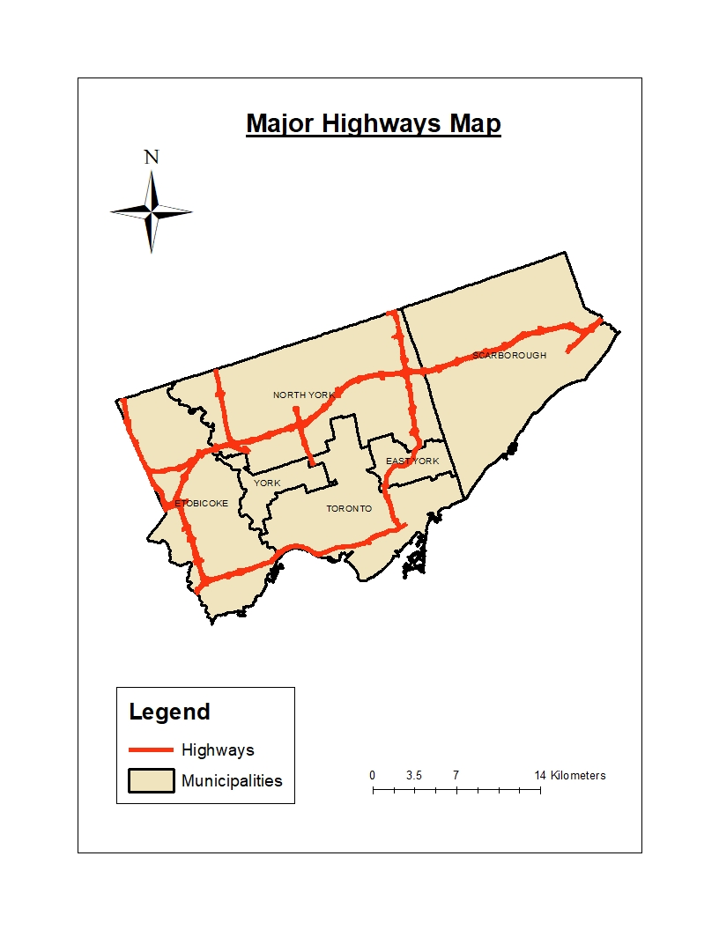
Highway 401 goes through Scarborough, North York and Etobicoke, Highway 427 goes vertically on the west side of Etobicoke, 400 goes vertically on the west side of North York, 409 goes through 401 and 427 in Etobicoke and highway 27 goes through 401,427 and 409 in Etobicoke. The areas that are well served are Etobicoke, North York and East York. The areas that are underserved are Scarborough, Toronto and York.

b)
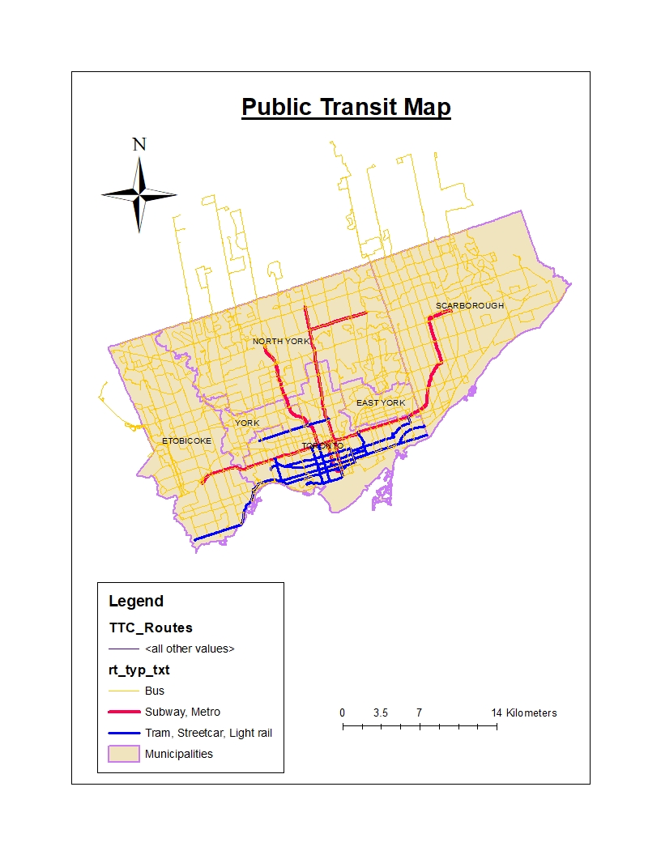
Bus routes exist throughout the entire whole city besides the north east corner of Scarborough. Subway routes exist heavily in Midtown and Downtown Toronto and then single routes stem out into Etobicoke, border of East York, Scarborough and two routes into North York. North York also has its own subway line called the Sheppard line. Street Car routes exist mainly in Downtown Toronto and stem out to Southeastern side of Toronto near East York and Scarborough. The routes also stem out to the south western side of Toronto with a route extending into Etobicoke. There is lone street car route in the Midtown part of Toronto, close to York. East York, Etobicoke, Scarborough and York are the least served while Toronto and North York are well served.
c)
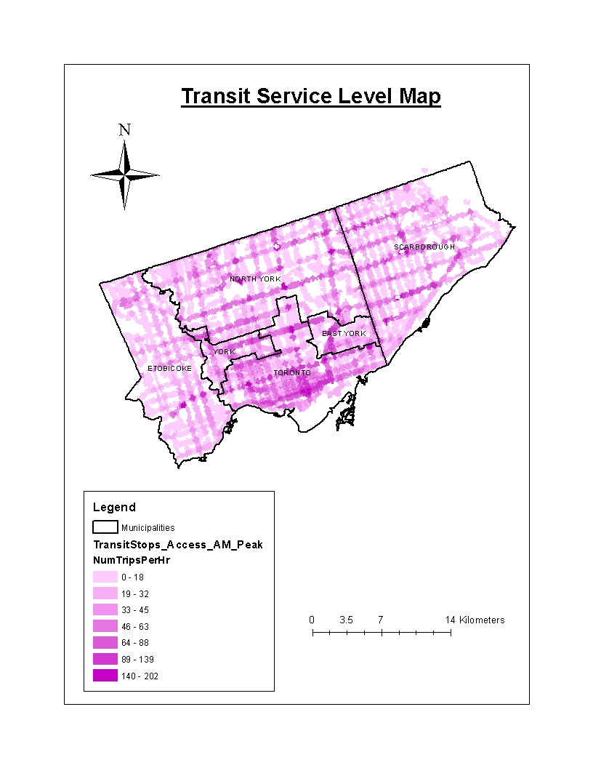
East York, York and Toronto have the most transit trips while North York, Etobicoke and Scarborough have the least transit trips. The spatial distribution of the map makes sense, according to Alonso Bid Rent theory. The theory states that as people live closer to the Central Business District, rent tends to go up and vice versa. It also states “for a given budget, people balance transportation costs with space costs.” (Lecture 3, Slide 15) This means that people living closer to Central Business District would not want to buy and drive a car, as they will live in close proximity to activities and so transit will have the lesser disutility because they do not have to spend time and/or money for parking, gas, maintenance, toll or time spent in rush hour traffic.
d)
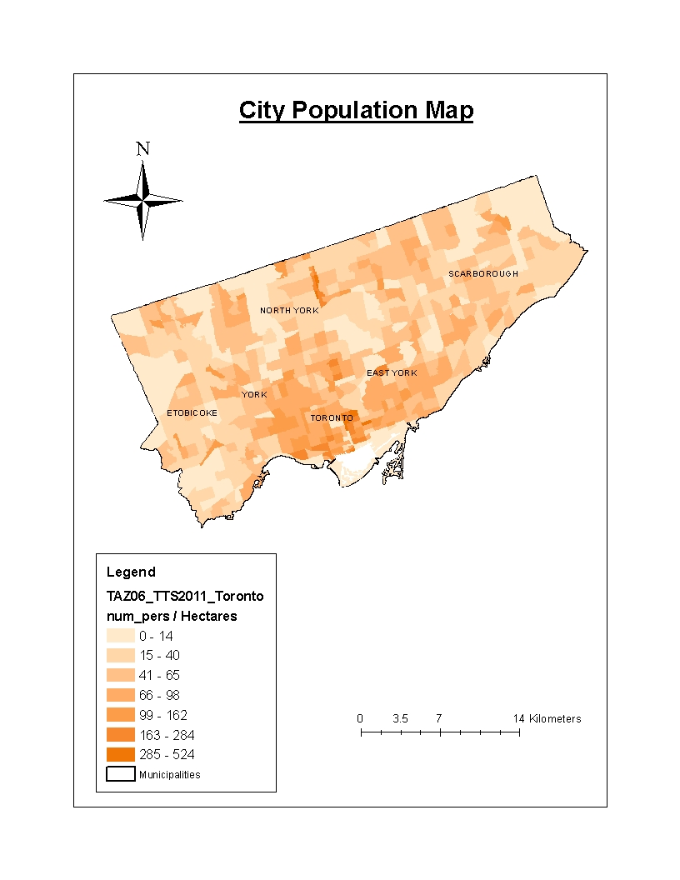
East York, York and Toronto have the densest neighbourhoods, while Etobicoke, North York and Scarborough have neighbourhoods that are the least dense. The density of population is heavily clustered in Toronto, York and East York region, while the density is relatively random elsewhere. From the map, it looks like the city is Polycentric as I see population hotspots in some of the municipalities such as North York, East York and Toronto municipality being the main population center. Scarborough and Etobicoke do not seem to have any population hotspots, as they tend to be more sprawled than the other municipalities. From my knowledge of living in Toronto for my whole life, there are definitely primary flows and secondary flows of people from these municipalities into the Toronto municipality and the other municipalities.
e)

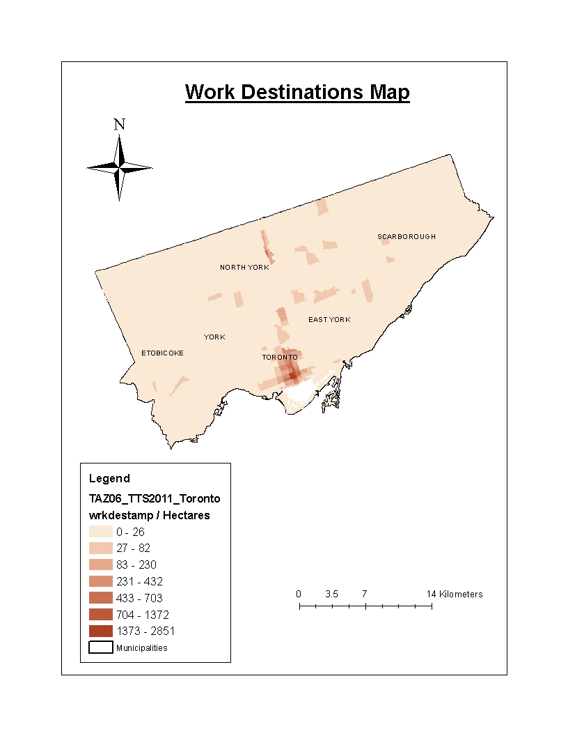
The densest employment neighbourhoods are in Downtown Toronto and a neighbourhood in North York. The other neighbourhoods are the least dense. Employment density is heavily clustered in the Downtown Toronto area, while it is more uniform than random elsewhere. From the map, the urban movement pattern for employment in the city is more monocentric than Polycentric, as I clearly see the Toronto municipality being the main Employment center. However, there is a little hotspot in North York. As a result, I infer that municipalities other than the Toronto municipality are more dispersed in employment, and there are huge primary flows of the population from these municipalities making work commutes to the Toronto municipality.

f)
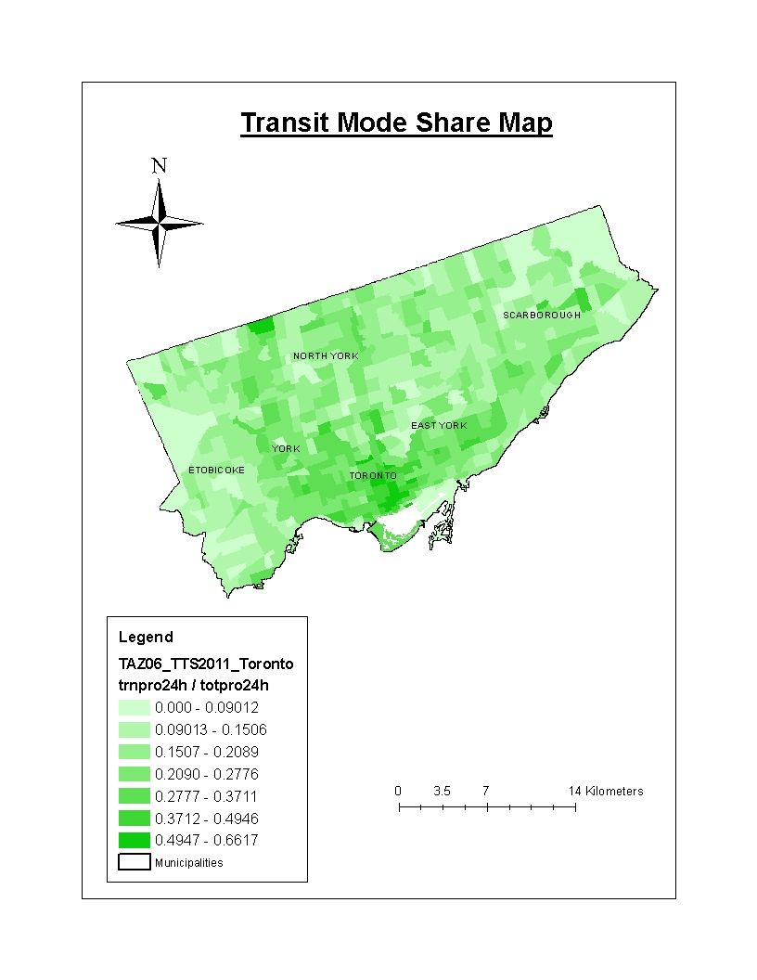
Transit Mode share is highest in Toronto and lowest in Etobicoke, Scarborough and North York. Transit Mode share is heavily clustered in Toronto, while it is random elsewhere. There is also a high area surrounded by low areas in Midtown Toronto because it looks like it is located near Yonge and Eglinton, which is a central business district of Toronto. Transit Mode share is clustered in and around the Toronto municipality, while Transit Mode share tends to be more dispersed outside of the Toronto municipality.

g)
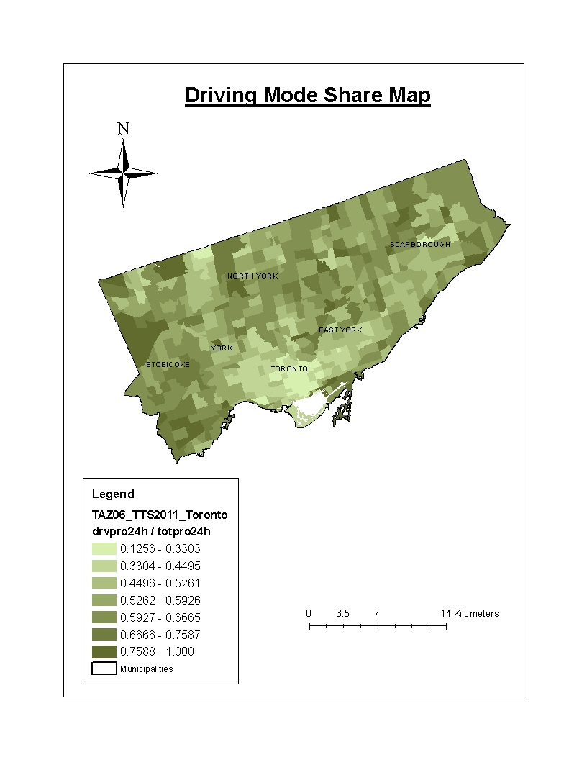
Driving Mode share is highest in Etobicoke, North York, East York and Scarborough, while York and Toronto tend to be lowest in Driving Mode share. Driving Mode share is pretty clustered everywhere except Toronto and York. Toronto and York are more uniform than random in terms of spatial patterns. Tommy Thompson Park where Toronto borders with Lake Ontario, is an outlier, in which it is a high area surrounded by low areas. This is probably because the park is most accessible by car, not transit. Another outlier is the location in the middle of Scarborough with the really pale green colour, which is a low Driver mode share area surrounded by mostly high Driver mode share areas. The reason for this location to occur like this is probably because it is where Scarborough Town Centre is, which is a location that is more accessible by TTC than driving, as it connects transit users to GO and TTC buses and also the Scarborough LRT.

Task 2 – Relationships and their Causal Inferences
Highway locations & driving mode share
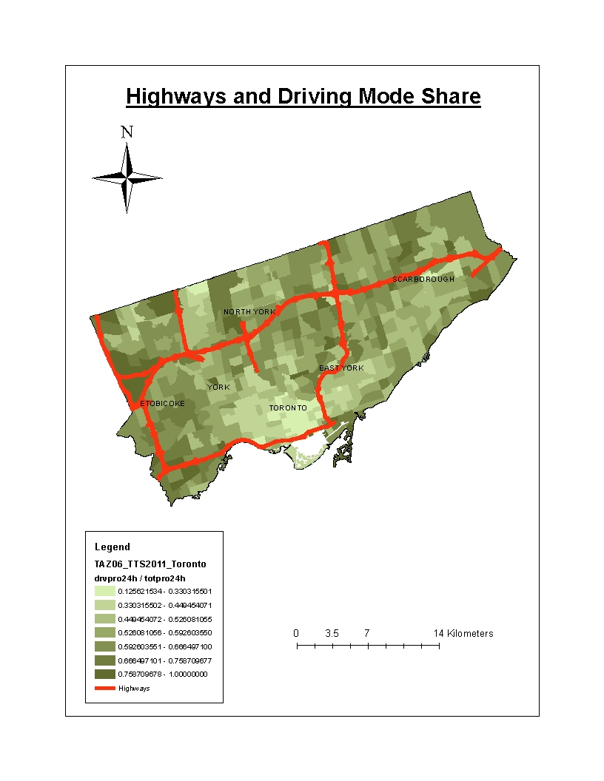
It looks like the Traffic Analysis Zones (TAZs) that are close to the highways tend to have high driving mode share with the exception of midtown and downtown Toronto. This is probably because since people leaving those TAZs have close proximity to the highway system, they find that incorporating driving in their daily trips, especially on the highway, would be the best way to minimize their disutility of traveling to the locations and/or activities that they are accessing. The disutility of travel typically stems from the cost and travel of their trip. However, the TAZs in Midtown and Downtown Toronto, especially close to the Gardiner Expressway, have low driver mode share because the bulk of locations and activities in the city are densely located in the Toronto municipality, such that they can be highly accessible by public transit.

Transit supply & transit mode share
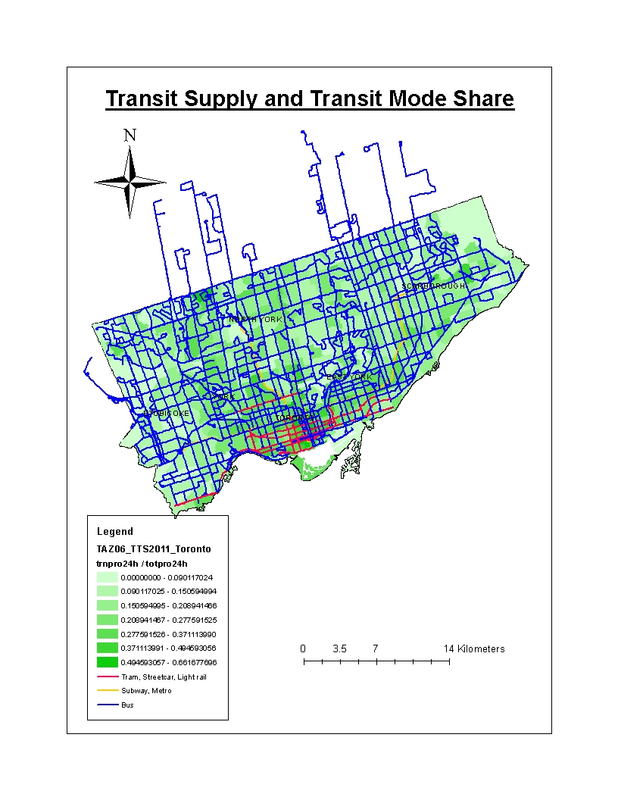
The highest supply of Transit is in downtown Toronto, as bus, streetcar and subway routes run all across through the region than any other region/municipality. As a result, Transit mode share will be highest in Downtown Toronto. This correlation is because Downtown Toronto is the center of all primary flows in terms of urban movement patterns, as it is where population density is highest in the city since it is where the bulk of the locations and activities of the city are. Therefore, the City of Toronto tries to make sure that the capacity of the public transit infrastructure can handle the large amounts of people using it.

Transit accessibility & transit mode share
Transit is most accessible in downtown Toronto, as buses, streetcars and subways run all across through the region than any other region/municipality. As a result, Transit mode share will be highest in Downtown Toronto. This correlation is because Downtown Toronto is the center of all primary flows in terms of urban movement patterns, as it is where population density is highest in the city since it is where the bulk of the locations and activities of the city are. Therefore, the City of Toronto tries to make sure that the capacity of the public transit infrastructure can handle the large amounts of people using it.

Population density & driving mode share
The Traffic Analysis Zones that are not dense in population tend to have higher driver mode share, while the TAZs that are densely populated tend to have lower driver mode share. This is most likely because the sparsely populated TAZS have less access to public transit, while the densely populated TAZs have far more access to public transit. This hypothesis follows the assumptions of the Transportation Land Use Cycle. As land use patterns (people building houses, commercial spaces, etc and settle and increase in population density in the region) develop, then activities (nightlife, shopping) develop so transportation systems have to be implemented in order for people to get where they need to conduct activities.

Population density & transit mode share
The Traffic Analysis Zones that are dense in population tend to have higher transit mode share, while the TAZs that are densely populated tend to have lower transit mode share. This is most likely because the sparsely populated TAZS have less access to public transit and will therefore certainly drive, while the densely populated TAZs have far more access to public transit. This hypothesis follows the assumptions of the Transportation Land Use Cycle. As land use patterns (people building houses, commercial spaces, etc and settle and increase in population density in the region) develop, then activities (nightlife, shopping, work and etc) develop so transportation systems have to be implemented in order for people to get where they need to conduct the activities.

Workplace density & driving mode share
We can see that downtown Toronto is the dense employment hub and tends to have the lowest driving mode share, while the areas outside downtown Toronto are mostly sparse in terms of the density of employment and tend to have driving mode shares higher than downtown’s. This is probably because the high workplace density in Downtown Toronto implies highly compact activity patterns and so public transit would be the mode of transportation with the highest mobility and accessibility. This hypothesis follows the assumptions of the Transportation Land Use Cycle. As activity patterns become more pronounced, there will be a need for various modes of transportation.

Workplace density & transit mode share

We can see that downtown Toronto is the dense employment hub and tends to have the highest transit mode share, while the areas outside downtown Toronto are mostly sparse in terms of the density of employment and tend to have transit mode shares lower than downtown’s. This is probably because the high workplace density in Downtown Toronto implies highly compact activity patterns and so driving would be the mode of transportation with the least mobility and accessibility. This hypothesis follows the assumptions of the Transportation Land Use Cycle. As activity patterns become more pronounced, there will be a need for modes of transportation.

Task 3 – Recommendations
The planning for “Infrastructure to support growth” for the Greater Golden Horseshoe involves: “providing connectivity among transportation modes for moving people and for moving goods and offering a balance of transportation choices that reduces the reliance upon the automobile and promotes transit and active transportation.” (Growth Plan for the Greater Golden Horseshoe (2017), pg. 33) The plan describes that funds should be spent on “facilitating improved linkages between and within municipalities from nearby neighbourhoods to urban growth areas, major transit station areas and other strategic growth areas” (Growth Plan for the Greater Golden Horseshoe (2017), pg. 34), which is a great idea for this initiative to be put forth. The reason why is because anywhere outside of the Toronto municipality is very reliant on automobiles, as we see high driver mode share. Expanding the transit supply further into the municipalities outside of Toronto will definitely decrease the reliance of automobiles and make growth toward the Greater Golden Horseshoe more appropriate and sustainable. There would be less congestion in the City of Toronto, as the population outside of the city would not entirely congest the city, as transit will alleviate the transportation stresses of the City of Toronto. This impact that I expect, goes according to the Transportation/Land Use Cycle. As the plan proposes we span our transportation systems further out of Toronto and into the Greater Golden Horseshoe, the city will make many locations outside of Toronto more accessible and this will attract investment and construction, such that the locations or regions will be for residential or commercial land uses. As a result, the population and activity patterns of the Greater Golden Horseshoe could be more spread out or decentralized than just mostly concentrated in Toronto.

Strategy 4 of the Draft 2041 RTP from Metrolinx proposes that Land Use and Transportations system should be integrated with one another, such that people live in “more connected and accessible communities that are supportive of transit, walking and cycling.” (Draft 2041, pg. 82) The city can work toward this goal by creating Major transit station areas also called “Mobility Hubs” (Draft 2041, pg. v). These mobility hubs will be sources of compact “residential and employment growth” (Draft 2041, pg. 84). This is a crucial driver for expanding transit outwards, in the Greater Toronto and Hamilton Area, as it will expand transit supply but also increase activity patterns, such that areas can be more accessible and investments toward residential and commercial land uses will be beneficial for the GTHA.

Strategy 2 of the Draft 2041 RTP from Metrolinx proposes that Frequent Rapid Transit should be implemented throughout the GTHA. An example of FRT is the TTC launching “its 10 Minute or Better service network for all streetcar routes and 52 bus routes.” (Draft 2041, pg. 53). If an initiative like this is implemented throughout GTHA, then “fast and reliable service” will be delivered to GTHA dwellers. To accomplish FRT, the city should use “transit priority measures such as queue jump lanes, signal priority at intersections, semi-exclusive or shared rights-of-way and wider spacing between stops.” (Draft 2041, pg. 57) In addition, the initiative states that “coordinated Regional Express Bus routes” (Draft 2041, pg. 61) should be developed as well as a “regional 24 hour transit network”. This initiative primarily addresses the need for investment towards the accessibility of transit services for the GTHA, so there can be sustainable growth of communities and activities in the GTHA. From the implementation of this initiative, we will definitely gain this outcome because according to the Transportation/Land Use Cycle, accessibility will undergo considerable improvements, such that land use patterns will develop and later activity patterns, which I mentioned previously.

References
Professor Steven Farber’s GGRC12 Lecture 3 slides
Growth Plan for the Greater Golden Horseshoe (2017). (2017, May). Retrieved February 12, 2018, from Growth Plan for the Greater Golden Horseshoe (2017)
DRAFT 2041 REGIONAL TRANSPORTATION PLAN FOR THE GREATER TORONTO AND HAMILTON AREA. (2017, September). Retrieved February 12, 2018, from https://www.metrolinxengage.com/sites/default/files/draft_rtp.pdf

